COBIT 5 2

COBIT 5 Principles 2

Governance & Management 2

Goals cascade 2

Process for Governance 3

Enablers 3

Enablers: Generic 3

Seven Phases of Implementation 4

COBIT 5 Process Capability Model 4

Risk Scenario Structure 5

Risk Model 5

IT Risk in the Risk Hierarchy 6

Risk Map and Risk Appetite 6

Risk IT Principles 6

Elements of Risk Culture 6

IT Risk Scenario Components 6

Risk Analysis & Response 6

IT Risk Register 6

Risk Scenarios Template 8

CRISC 5 Practice Domains 8

Domain 1—Risk Identification, Assessment and Evaluation 8

Domain 2—Risk Response 8

Domain 3—Risk Monitoring 8

Domain 4—Information Systems Control Design and Implementation 8

Domain 5—IS Control Monitoring and Maintenance 9

Information Security Management 9

SABSA Security Matrix 9

Defense in depth by Function 9

Enterprise Architecture 10

TOGAF 9 Content Overview 10

Architecture Development Method (ADM) 10

Program Management Process (Ricardo Vargas) 11

Traceability Matrix 11

Benefits Realization 11

Managerial Tools, Techniques 12

Constraint Analysis 12

Cause and Effect 12

Tornado Diagram 12

Check list 13

Influence Diagram 13

Root Cause Analysis 13

Probability and Impact Calculation 13

Probability and Impact Matrix 13

FMEA Diagram 13

Fault Tree Analysis 13

Risk Breakdown Structure 13

Decision Tree 13

Risk Heat Map 13

DMAIC Tools Map 14

PM Toolkit 15

Six Sigma and Lean Management 16

SIPOC 16

House of Quality 16

VOP and VOC 16

Process Map 16

Lean Project Plan 17

Sample Operating Model (for Finance) 17

UML Documentation 18

Subsystem Layering Diagram 18

Subsystem Component Diagram 18

Package Layering 18

Component Packaging 18

Application Domain 18

ASP.Net Threading 18

Batch Job Threading Model 18

Deployment Model 18

Development Environment System View 18

Flow Diagram 18

Web application Boundary 18

Data Retrieval 18

Data Persistence 18

Exception Handling 18

USE CASE Template 19

AGILE Tool 19

Burn down 19

Burn Up 19

Chart (Gantt) vs Task Board 19

Coaching 19

Planning – Remember the Future 20

Planning Prune the Product Tree 20

Planning Sppedboat 20

Persona 20

Planning Poker 20

Story Map 20

Scrum Board 20

Timeline (problem analysis) 20

Value Based 20

Wideband Delphi 20

Iteration Burndown Excel 21

JIRA Team Scrum Board 21

Kanban 21

CA Clarity Kanban, backlog, chart 21

Planview Burndown, metrics 21

Requirements Management Life Cycle (RMLC) 21

Requirement Artifacts 21

Requirement Skills 22

Requirements Fast Facts 22

.

## COBIT 5

|  |  |
| --- | --- |
| COBIT 5 Principles  Governance & Management | Goals cascade |

#### Process for Governance

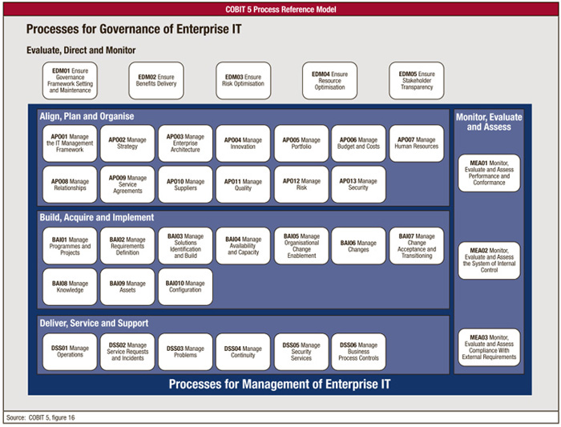

|  |  |
| --- | --- |
| Enablers | Enablers: Generic |

#### Seven Phases of Implementation

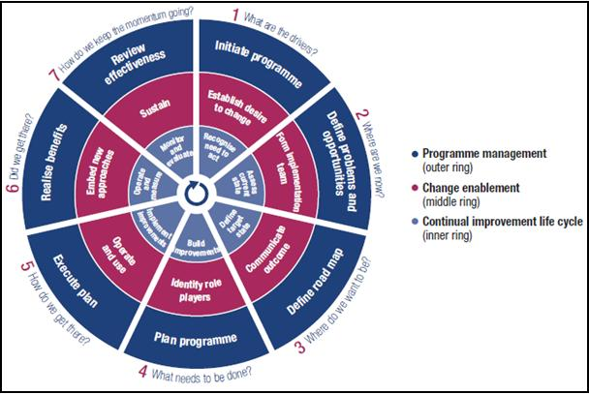

#### COBIT 5 Process Capability Model

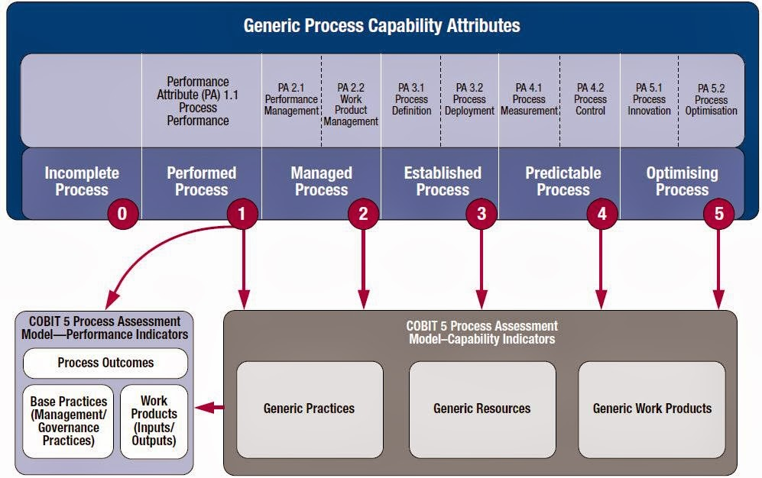

#### Risk Scenario Structure

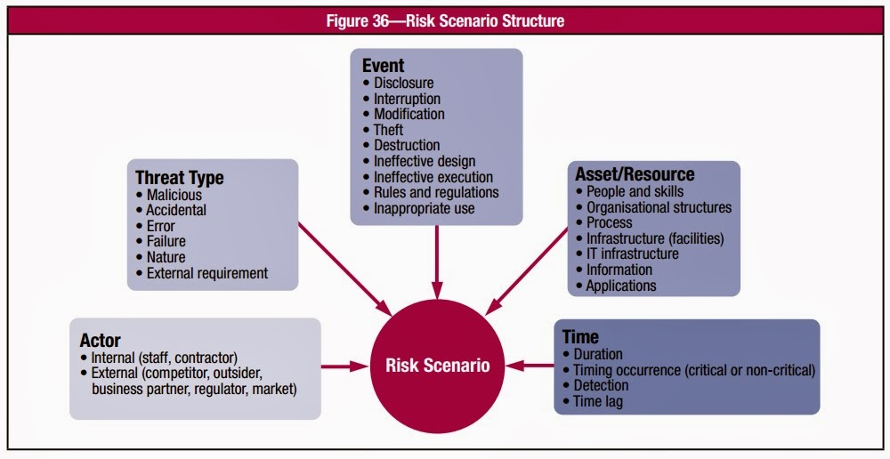

#### Risk Model

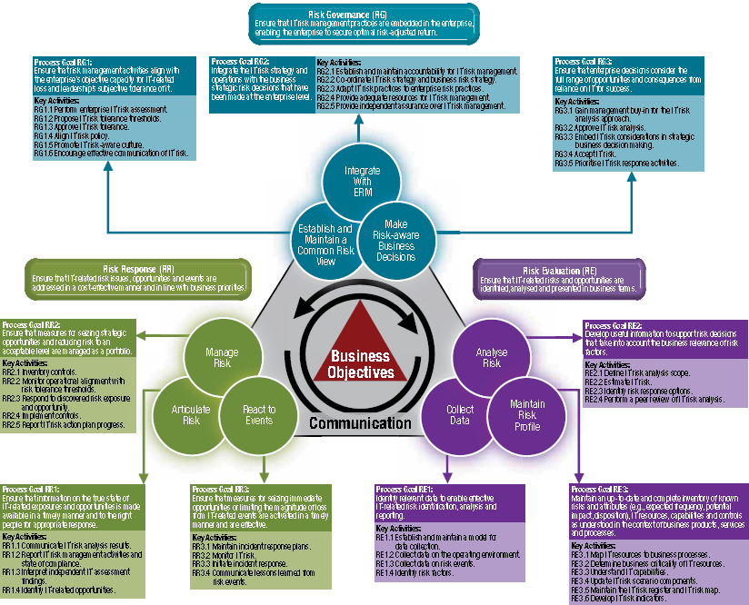

|  |  |
| --- | --- |
| IT Risk in the Risk Hierarchy | Risk Map and Risk Appetite |

See COBIT

|  |  |  |
| --- | --- | --- |
| Risk IT Principles | Elements of Risk Culture | IT Risk Scenario Components |

#### Risk Analysis & Response

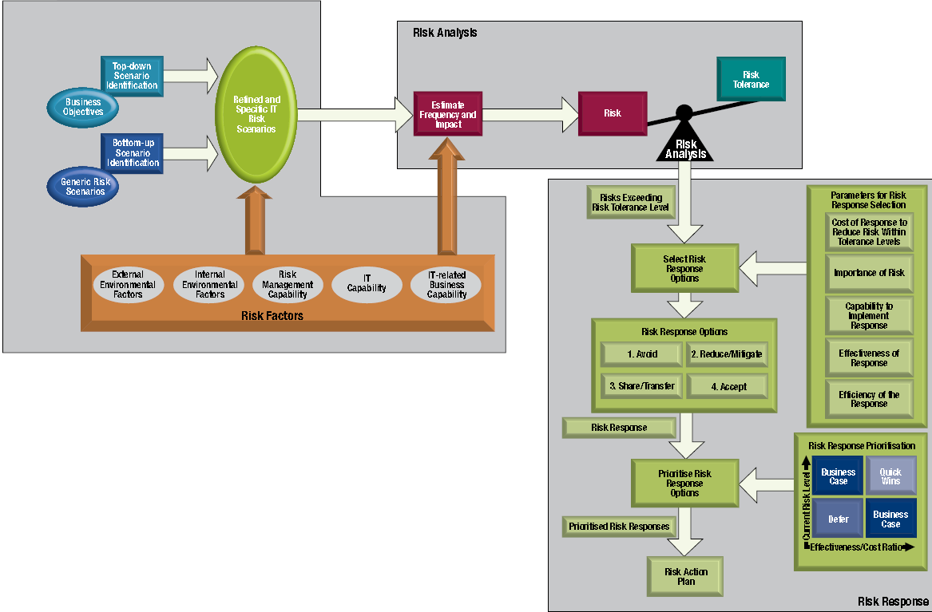

#### IT Risk Register

| **Template Risk Register Entry** | | | | | | | | | | | | | | | | |
| --- | --- | --- | --- | --- | --- | --- | --- | --- | --- | --- | --- | --- | --- | --- | --- | --- |
| **Part I—Summary Data** | | | | | | | | | | | | | | | | |
| **Risk statement** |  | | | | | | | | | | | | | | | |
| **Risk owner** |  | | | | | | | | | | | | | | | |
| **Date of last risk assessment** |  | | | | | | | | | | | | | | | |
| **Due date for update of risk assessment** |  | | | | | | | | | | | | | | | |
| **Risk category** | **🞏 Strategic**  **(IT benefit/value enablement)** | | | | | **🞏 Project Delivery**  **(IT program and project delivery)** | | | | | **🞏 Operational**  **(IT operations and service delivery)** | | | | | |
| **Risk classification (copied from risk analysis results)** | **🞏 Low** | | | **🞏 Medium** | | | | | **🞏 High** | | | | | **🞏 Very high** | | |
| **Risk response** | **🞏 Accept** | | | **🞏 Transfer** | | | | | **🞏 Mitigate** | | | | | **🞏 Avoid** | | |
| **Part II—Risk Description** | | | | | | | | | | | | | | | | |
| **Title** |  | | | | | | | | | | | | | | | |
| **High-level scenario (from list of sample high level scenarios)** |  | | | | | | | | | | | | | | | |
| **Detailed scenario description—scenario components** | Actor | |  | | | | | | | | | | | | | |
| Threat type | |  | | | | | | | | | | | | | |
| Event | |  | | | | | | | | | | | | | |
| Asset/resource | |  | | | | | | | | | | | | | |
| Timing | |  | | | | | | | | | | | | | |
| **Other scenario information** |  | | | | | | | | | | | | | | | |
| **Part III—Risk Analysis Results** | | | | | | | | | | | | | | | | |
| **Frequency of scenario (# times per year)** | **0** | **1** | | | **2** | | | **3** | | | | **4** | | | | **5** |
| **N≤0.01**  **🞏** | **0.01<N≤0.1**  **🞏** | | | **0.1<N≤1**  **🞏** | | | **1<N≤10**  **🞏** | | | | **10<N≤100**  **🞏** | | | | **100<N**  **🞏** |
| **Comments on frequency** |  | | | | | | | | | | | | | | | |
| **Impact of scenario on business** | **0** | **1** | | | **2** | | | **3** | | | | **4** | | | | **5** |
| 1. **Productivity** | **Revenue loss over one year** | | | | | | | | | | | | | | | |
| **Impact rating** | **I≤0.1%**  **🞏** | **0.1%<I≤1%**  **🞏** | | | **1%<I≤3%**  **🞏** | | | **3%<I≤5%**  **🞏** | | | | **5%<I≤10%**  **🞏** | | | | **10%<I**  **🞏** |
| **Detailed description of impact** |  | | | | | | | | | | | | | | | |
| 1. **Cost of response** | **Expenses associated with managing the loss event (US $)** | | | | | | | | | | | | | | | |
| **Impact rating** | **I≤10k$**  **🞏** | **10k$<I≤100k$**  **🞏** | | | **100k$<I≤1M$**  **🞏** | | | **1M$%<I≤10M$**  **🞏** | | | | **10m$<I≤100M$**  **🞏** | | | | **100M$<I**  **🞏** |
| **Detailed description of impact** |  | | | | | | | | | | | | | | | |
| 1. **Competitive advantage** | **Drop in customer satisfaction ratings** | | | | | | | | | | | | | | | |
| **Impact rating** | **I≤0.5**  **🞏** | **0.5<I≤1**  **🞏** | | | **1<I≤1,5**  **🞏** | | | **1,57<I≤2**  **🞏** | | | | **2<I≤2,5**  **🞏** | | | | **2,5<I**  **🞏** |
| **Detailed description of impact** |  | | | | | | | | | | | | | | | |
| 1. **Legal** | **Regulatory compliance—Fines (US $)** | | | | | | | | | | | | | | | |
| **Impact rating** | **None**  **🞏** | **< 1m$**  **🞏** | | | **<10m$**  **🞏** | | | **<100M$**  **🞏** | | | | **<1B$**  **🞏** | | | | **>1B$**  **🞏** |
| **Detailed description of impact** |  | | | | | | | | | | | | | | | |
| **Overall Impact rating (average of four impact ratings)** |  | | | | | | | | | | | | | | | |
| **Overall rating of risk, obtained by combining frequency and impact ratings on risk map** | **🞏 Low** | | | **🞏 Medium** | | | **🞏 High** | | | | | | **🞏 Very high** | | | |
| **Part IV—Risk Response** | | | | | | | | | | | | | | | | |
| **Risk response for this risk** | **🞏 Accept** | | | **🞏 Transfer** | | | | | **🞏 Mitigate** | | | | | | **🞏 Avoid** | |
| **Justification** |  | | | | | | | | | | | | | | | |
| **Detailed description of response (not in case of ‘accept’)** | **Response Action** | | | | | | | | | **Completed** | | | | | **Action Plan** | |
|  | | | | | | | | | **🞏** | | | | | **🞏** | |
|  | | | | | | | | | **🞏** | | | | | **🞏** | |
| **Overall status of risk action plan** |  | | | | | | | | | | | | | | | |
| **Major issues with risk action plan** |  | | | | | | | | | | | | | | | |
| **Overall status of completed responses** |  | | | | | | | | | | | | | | | |
| **Major issues with completed responses** |  | | | | | | | | | | | | | | | |
| **Part V—Risk Indicators** | | | | | | | | | | | | | | | | |
| **Key risk indicators** **(12) for this risk** | **1.**  ***2.***  ***3.*** | | | | | | | | | | | | | | | |

#### Risk Scenarios Template

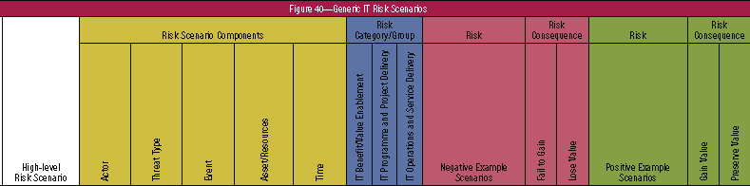

## CRISC 5 Practice Domains

Domain 1—Risk Identification, Assessment and Evaluation (31%) Domain 2—Risk Response (17%) Domain 3—Risk Monitoring (17%) Domain 4—Information Systems Control Design and Implementation (17%) Domain 5—IS Control Monitoring and Maintenance (18%) 🕮**IT Risk Management**

#### Domain 1—Risk Identification, Assessment and Evaluation

Identify, assess and evaluate risk to enable the execution of the enterprise risk management strategy.

|  |  |
| --- | --- |
| Domain 1—Task Statements **1.1** Collect information & review documentation to ensure that **risk scenarios** are identified and evaluated **1.2** Identify legal, regulatory and contractual requirements and organizational policies and standards related to information systems to determine their potential impact on the business objectives **1.3** Identify potential threats and vulnerabilities for business processes, associated data and supporting capabilities to assist in the evaluation of enterprise risk **1.4** Create and maintain a **risk register** to ensure that all identified risk factors are accounted for **1.5** Assemble risk scenarios to estimate the likelihood and impact of significant events to the organization **1.6** Analyze risk scenarios to determine their impact on business objectives **1.7** Develop a risk awareness program and conduct training to ensure that stakeholders understand risk and contribute to the risk management process and to promote a risk-aware culture **1.8** Correlate identified risk scenarios to relevant business processes to assist in identifying risk ownership **1.9** Validate **risk appetite and tolerance** with senior leadership and key stakeholders to ensure alignment | Domain 1—Knowledge Statements **1.1** Knowledge of standards, frameworks and leading practices related to **risk identification, assessment and evaluation** **1.2** Knowledge of techniques for risk identification, classification, assessment and evaluation **1.3** Knowledge of quantitative and qualitative **risk evaluation** methods **1.4** Knowledge of business goals and objectives **1.5** Knowledge of organizational structures **1.6** Knowledge of risk scenarios related to business processes and initiatives **1.7** Knowledge of business information criteria **1.8** Knowledge of **information systems architecture** (e.g. platforms, networks, application, databases and operating systems) **1.9** Knowledge of **information security** concepts **1.10** Knowledge of **threats and vulnerabilities** related to (**1.10** business processes and initiatives **1.11** third-party management **1.12** data management **1.13** system development life cycle **1.14** project and program management **1.15** business continuity and disaster recovery management **1.16** management of IT operations **1.17** emerging technologies) **1.18** Knowledge of the elements of a risk register **1.19** Knowledge of **risk scenario development tools & techniques** **1.20** Knowledge of risk awareness training tools and techniques **1.21** Knowledge of principles of risk ownership **1.22** Knowledge of current and forthcoming laws, regulations and standards |

#### Domain 2—Risk Response

Develop and implement risk responses to ensure that risk factors and events are addressed in a cost-effective manner and in line with business objectives

|  |  |
| --- | --- |
| Domain 2—Task Statements **2.1** Identify and evaluate risk response options and provide management with information to enable risk response decisions **2.2** Review risk responses with the relevant stakeholders for validation of efficiency, effectiveness and economy **2.3** Apply risk criteria to assist in the development of the risk profile for management approval **2.4** Assist in the development of risk response action plans to address risk factors identified in the organizational risk profile **2.5** Assist in the development of business cases supporting the investment plan to ensure risk responses are aligned with the identified business objectives | Domain 2—Knowledge Statements **2.1** Knowledge of standards, frameworks and leading practices related to risk response **2.2** Knowledge of risk response options **2.3** Knowledge of cost-benefit analysis and return on investment (ROI) **2.4** Knowledge of risk appetite and tolerance **2.5** Knowledge of organizational risk management policies **2.6** Knowledge of parameters for risk response selection **2.7** Knowledge of project management tools and techniques **2.8** Knowledge of portfolio, investment and value management **2.9** Knowledge of exception management **2.10** Knowledge of residual risk |

#### Domain 3—Risk Monitoring

Monitor risk and communicate information to the relevant stakeholders to ensure the continued effectiveness of the enterprise’s risk management strategy.

|  |  |
| --- | --- |
| Domain 3—Task Statements **3.1** Collect and validate data that measure key risk indicators (KRIs) to monitor and communicate their status to relevant stakeholders **3.2** Monitor and communicate key risk indicators (KRIs) and management activities to assist relevant stakeholders in their decision-making process **3.3** Facilitate independent risk assessments and risk management process reviews to ensure they are performed efficiently and effectively **3.4** Identify and report on risk, including compliance, to initiate corrective action and meet business and regulatory requirements | Domain 3—Knowledge Statements **3.1** Knowledge of standards, frameworks and leading practices related to risk monitoring **3.2** Knowledge of principles of risk ownership **3.3** Knowledge of risk and compliance reporting requirements, tools and techniques **3.4** Knowledge of key performance indicator (KPIs) and key risk indicators (KRIs) **3.5** Knowledge of risk assessment methodologies **3.6** Knowledge of data extraction, validation, aggregation and analysis tools and techniques **3.7** Knowledge of various types of reviews of the organization’s risk monitoring process (e.g. internal and external audits, peer reviews, regulatory reviews, quality reviews) |

#### Domain 4—Information Systems Control Design and Implementation

Design and implement information systems controls in alignment with the organization’s risk appetite and tolerance levels to support business objectives.

|  |  |
| --- | --- |
| Domain 4—Task Statements **4.1** Interview process owners and review process design documentation to gain an understanding of the business process objectives **4.2** Analyze and document business process objectives and design to identify required information systems controls **4.3** Design information systems controls in consultation with process owners to ensure alignment with business needs and objectives **4.4** Facilitate the identification of resources (e.g., people, infrastructure, information, architecture) required to implement and operate information systems controls at an optimal level **4.5** Monitor the information systems control design and implementation process to ensure that it is implemented effectively and within time, budget and scope **4.6** Provide progress reports on the implementation of information systems controls to inform stakeholders and to ensure that deviations are promptly addressed **4.7** Test information systems controls to verify effectiveness and efficiency prior to implementation  **4.8** Implement information systems controls to mitigate risk **4.9** Facilitate the identification of metrics and key performance indicators (KPIs) to enable the measurement of information systems control performance in meeting business objectives **4.10** Assess and recommend tools to automate information systems control processes **4.11** Provide documentation and training to ensure information systems controls are effectively performed **4.12** Ensure all controls are assigned control owners to establish accountability **4.13** Establish control criteria to enable control life cycle management | Domain 4—Knowledge Statements **4.1** Knowledge of standards, frameworks and leading practices related to information systems control design and implementation **4.2** Knowledge of business process review tools and techniques **4.3** Knowledge of testing methodologies and practices related to information systems control design and implementation **4.4** Knowledge of control practices related to business processes and initiatives **4.5** Knowledge of the information systems architecture (e.g., platforms, networks, application, databases and operating systems) **4.6** Knowledge of controls related to information security **4.7** Knowledge of controls related to third-party management **4.8** Knowledge of controls related to data management **4.9** Knowledge of controls related to the system development life cycle **4.10** Knowledge of controls related to project and program management **4.11** Knowledge of controls related to business continuity and disaster recovery management **4.12** Knowledge of controls related to management of IT operations **4.13** Knowledge of SW and HW certification and accreditation practices **4.14** Knowledge of the concept of control objectives **4.15** Knowledge of governance, risk and compliance (GRC) tools **4.16** Knowledge of tools and techniques to educate and train users |

#### Domain 5—IS Control Monitoring and Maintenance

Monitor and maintain information systems controls to ensure they function effectively and efficiently.

|  |  |
| --- | --- |
| Domain 5—Task Statements **5.1** Plan, supervise and conduct testing to confirm continuous efficiency and effectiveness of information systems controls **5.2** Collect information and review documentation to identify information systems control deficiencies **5.3** Review information systems policies, standards and procedures to verify that they address the organization's internal and external requirements **5.4** Assess and recommend tools and techniques to automate information systems control verification processes **5.5** Evaluate the current state of information systems processes using a maturity model to identify the gaps between current and targeted process maturity **5.6** Determine the approach to correct information systems control deficiencies and maturity gaps to ensure that deficiencies are appropriately considered and remediated **5.7** Maintain sufficient, adequate evidence to support conclusions on the existence and operating effectiveness of information systems controls **5.8** Provide information systems control status reporting to relevant stakeholders to enable informed decision making. | Domain 5—Knowledge Statements **5.1** Knowledge of standards, frameworks and leading practices related to information systems control monitoring and maintenance **5.2** Knowledge of enterprise security architecture **5.3** Knowledge of monitoring tools and techniques **5.4** Knowledge of maturity models - Knowledge of control objectives, activities and metrics related to (**5.5** IT operations and business processes and initiatives **5.6** Incident and problem management **5.7** architecture (platforms, networks, application, databases and operating systems) **5.8** information security **5.9** Third-party management **5.10** Data management **5.11** System development life cycle **5.12** Project and program management **5.13** Software and hardware certification and accreditation practices **5.14** Business continuity and disaster recovery management) **5.15** Knowledge of security testing and assessment tools and techniques **5.16** Knowledge of applicable laws and regulations |

## Information Security Management

#### SABSA Security Matrix

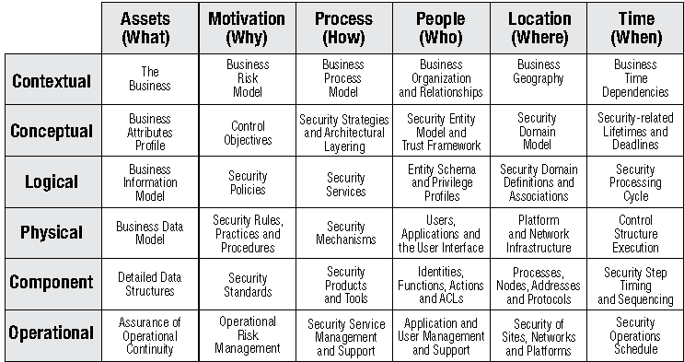

#### Defense in depth by Function

|  |  |  |  |
| --- | --- | --- | --- |
| **Defenses Against System Compromise** | **Policies, Standards, Procedures, Technology** | **Defenses Against System Compromise** | **Policies, Standards, Procedures, Technology** |
| **Prevention** | ⬩Authentication ⬩Authorization ⬩Encryption ⬩Firewalls ⬩Data labeling/handling/retention ⬩Management ⬩Physical security ⬩Intrusion prevention ⬩Virus scanning ⬩Personnel security ⬩Awareness and training | **Containment** | ⬩Authorization ⬩Data privacy ⬩Firewalls/security domains ⬩Network segmentation ⬩Physical security |
| **Detection/notification** | ⬩Monitoring ⬩Measurements/metrics ⬩Auditing/logging ⬩Honeypots ⬩Intrusion detection ⬩Virus detection | **Reaction Incident response** | ⬩Policy/procedure change ⬩Additional security mechanisms ⬩New/better controls |
| **Evidence collection/**  **event tracking** | ⬩Auditing/logging ⬩Management/monitoring ⬩Nonrepudiation ⬩Forensics | **Recovery/restoration** | ⬩Backups/restoration ⬩Failover/remote sites ⬩Business continuity/disaster recovery planning |

## Enterprise Architecture

#### TOGAF 9 Content Overview

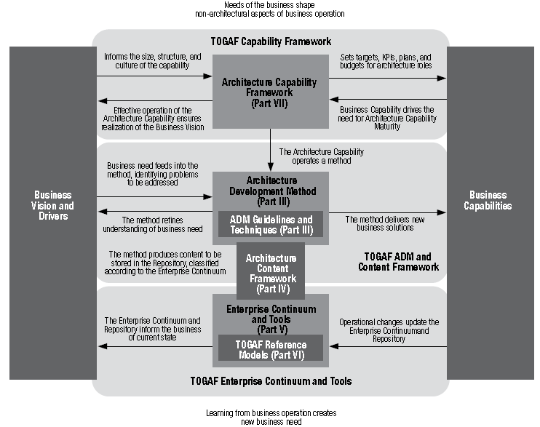

#### Architecture Development Method (ADM)

|  |  |
| --- | --- |
| **9 Phases 🄌**Preliminary Phase ➊ Requirements Management ➋Phase A:  Architecture Vision ➌Phase B:Business Architecture ➍Phase C:Information Systems Architectures ➎Phase D:Technology Architecture ➏Phase E:Opportunities & Solutions ➐Phase F:Migration Planning➑Phase G:Implementation Governance ➒Phase H:Architecture Change Management |  |

## Program Management Process (Ricardo Vargas)

|  |  |
| --- | --- |
|  |  |

## Traceability Matrix

|  |  |
| --- | --- |
|  |  |

## Benefits Realization

|  |  |  |  |  |  |  |  |
| --- | --- | --- | --- | --- | --- | --- | --- |
| **REALIZATION** | | | | **MONITORING** | | | |
| **BENEFIT ITEM** | **IMPACT** | **REALIZATION STRATEGY** | **DRIVER** | **MONITORING STRATEGY** | **START DATE** | **FREQUENCY** | **REVIEW BODY** |
| **Eliminate system unavailability during EOD processes** | Increased productivity | Usage of system during EOD processes | Channel Operations Manger | Conduct user satisfaction survey | Oct-13 | Monthly | GOTD -Snr General Manager |
| **Increase flexibility in product pricing** | Introduction of behavioral and risk based pricing | On going and introductory special offers to customers based on behavior and risk scores | Product Development and Portfolio Manager | Monthly report on accounts affected by product pricing changes | Oct-13 | Monthly | TCBD - General Manager / CRM- General Manager |
| **Improvement in fraud management capabilities** | Real-time monitor transactions, improve service to customers, reduce in fraud related losses | Usage of new fraud tools | Fraud Manager | Monthly reports on fraud cases | Oct-13 | Monthly | GOTD - Snr General Manager |
| **Core banking systems interfacing (e.g. FINACLE)** | Straight through processing of transactions across systems | Introduction of additional services to customer including standing order processing | Product Development, Portfolio Manager and Channel Operations Manger | Monthly report on transactions across systems | Oct-13 | Monthly | TCBD - Assistant General Manager / Snr General Manager |
| **Reward management** | Full loyalty strategy for multiple rewards + recognition programs | Introduction of integrated merchant and card holder rewards programs | Product Development and Portfolio Manager | Merchant and Card Holder rewards report | Oct-13 | Monthly | TCBD - Assistant General Manager / Snr General Mgr |
| **POS Inventory management** | Effective tracking & management of terminal inventory | Account for terminals using new system | Product Development and Portfolio Manager | Monthly POS terminal location report | Oct-13 | Monthly | TCBD - Assistant General Manager / Snr General Mgr |
| **Portfolio management** | Improved Analytics Capabilities | Effectively analyze key metrics to inform business strategic decisions | Product Development and Portfolio Manager | Monthly portfolio report on key metrics | Oct-13 | Monthly | TCBD - Assistant General Manager / Snr General Mgr |
| **Quickly modify or create products** | Ability to create or modify product in response to market changes | Introduce new products and modify existing product features | Product Development and Portfolio Manager | Track time is takes to develop or modify a product | Oct-13 | Monthly | TCBD - Assistant General Manager / Snr General Mgr |
| **Improvement in operating efficiency** | Increased productivity and reduction processing time | New system will handle processes that were previously handled manually | Operations Mangers | Conduct user satisfaction survey | Oct-13 | Quarterly | TCBD & GOTD - Assistant General Mgr / Snr Gen Mgr |
| **Incremental increase in revenue** | Increase in overall revenue | Monthly tracking and analysis | Business & Channel Analysts | Trial balance and Management reports | Oct-13 | Monthly | TCBD - Assistant General Manager / Snr Gen Manager |

## Managerial Tools, Techniques

|  |  |
| --- | --- |
| Constraint Analysis | Cause and Effect |
| Tornado Diagram | **Tornado diagrams** are useful for deterministic sensitivity analysis - comparing the relative importance of variables. For each variable/uncertainty considered, you will need estimates for what the low, base, and high outcomes would be. The sensitive variable is modeled as uncertain value while all other variables are held at baseline values (stable) |

|  |  |
| --- | --- |
| Check list  Influence DiagramRoot Cause Analysis  Probability and Impact Calculation  Probability and Impact Matrix  FMEA Diagram **FMEA** | Fault Tree Analysis  Risk Breakdown Structure  Decision Tree  Risk Heat Map |

#### DMAIC Tools Map

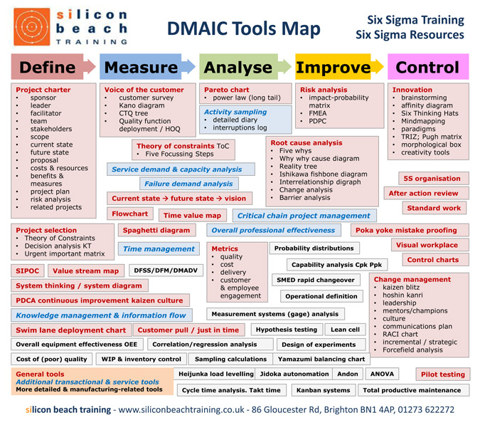

**ARIS Loves SIX SIGMA**

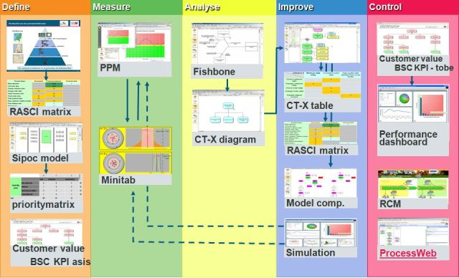

## PM Toolkit

Tools for Project Management, Workshops and Consulting by Nicolai Andler

|  |  |  |  |
| --- | --- | --- | --- |
| * Project Charter * Statement of Work * Project Initiation Document * Project Kickoff Meeting Agenda * Project Management Plan * Scope Management Plan * Schedule Management Plan * Cost Management Plan * Human Resource (HR) Management Plan * Communication Management Plan * Change Management Plan * Defect Management Plan * Quality Management Plan * Risk Management Plan * Strategies for Risk Response Planning | * Strategy for Threat * Strategy for Opportunity * Strategy for Threats and Opportunities * Supporting Project Management Plans * Procurement Management Plan * Configuration Management (CM) Plan * Knowledge Management (KM) Plan * Transition Plan * Environmental Management Plan (EMP) * Change Request Document * Risk Heat Map * Project Handbook * Project Status Report * Milestone Report * Meeting Agenda and Meeting Minutes | * Document * Project Closure Report * Lessons Learned Document * Email Etiquette * Microsoft PowerPoint * Gantt Chart * Flowchart * S-Curve * Column Chart * Resource Histogram * Run Chart * Pareto Chart * Cause-and-Effect Diagram * Pie Chart * Control Chart | * Organization Chart * Work Breakdown Structure (WBS) * Decision Tree Diagram * Responsibility Assignment Matrix (RAM) * Role and Responsibility Matrix * Communication Matrix * Project Team Roster * Risk Probability–Impact Matrix * Risk Register * Requirements Traceability Matrix (RTM) * Quality Matrix * Issue Log * Project Dashboard * Pivot Table |
| Project planning and definition  * **Agree on methodology and approach for Project** - Not available * **Question** **project sponsor/ stakeholders on project objectives & business goals** Goal catalogue (4.5), Charter (4.4), Project roadmap/ program (7.4) * **Problem identification, project motivation, project brief clarification, project set-up and approval** Project idea/ concept/ proposal, Business case, Program/ portfolio management, Problem definition (3.1.1), Project contract (7.2), Log Frame (7.3), Charter (4.4) * **Project & activities definition (Annex A – Check Questions (8) & Annex B – Scenarios & tool lists (9) for quality assurance** Various tools in Definition of situation/ problem (3.1), Charter (4.4) * **Define and agree on high level project setup and organization** Project brief, Project contract (7.2), Project handbook * **Costs, revenue, efforts estimation** Business case * **Project initiation/ planning, deconstruction & definition of project elements** Tools in project management * **Identification and understanding of stakeholders** stakeholder-related tools in the category Definition of a situation/ problem (3.1) * **Project components and resulting activities** Work breakdown structure (7.5), Project work plan (7.7) * **Decide on sequence and timing of tasks** Task schedule * **Establish project plan with work & duration** Task schedule, Gantt chart (7.6) * **Analyze and understand project environment** Project environment analysis (7.8) * **Plan/ assign resources** Resource plan * **Estimate** **and calculate costs** Cost plan/estimate, Cost calculation/ estimation model, Budget calculation, Business case * **Assign** **project roles/ responsibilities** Project management roles& responsibilities (7.10), Accountability matrix (CIDA) (7.12) * **Decide on project set-up, org., team members, governance, reporting lines & communication needs** Project contract (7.2), Project communication plan (7.11) * **Detect project & business risks** Risk analysis (6.14), Risk management plan * **Establish resource & equipment plan** Resource and equipment plan * **Define documentation/ information requirements/ standards** Documentation & information policy plan * **Define QA policy** QA policy plan * **Define contractual and service delivery policies** Service delivery policy, procurement policy, SLA framework * **Consolidate and document into a single source file** Project contract (7.2), LogFrame (7.3), Project handbook/ manual (Project Definition Report) | Strategic analysis  * **What are core processes that create value/ competitive position? How does company work & function? What are products and services?** Value chain analysis (5.3.1) * **‘High-level’ functions that company performs (to understand critical success factors)** Functional decomposition (5.2.3) * **Basic competencies and success factors? What gives the competitive edge and ensures survival? (To understand internal aspects of the SWOT analysis)** Critical success factor (CSF) (5.3.2) * **In what phase of its life cycle is the company? What are the typical signs and verification points? What are the typical symptoms and issues? (external perspective)** Life cycle (5.3.4) * **Who are the competitors and what is the competition like**? Competitor analysis (5.3.6) * **Current / potential future target groups/ segments**? Customer segmentation (5.3.9) * **Strategic development options & directions – based on the current understanding? Start to construct and engineer options** SWOT and TOWS (5.3.3) * **What are potential options and combinations to create new options for expansions and enhancements? A constructive product/market brainstorming – which combinations make sense**? Product/market mix (5.3.12) * **Other types of strategic development options**? Strategic development options (5.3.13), Strategy matrix (5.3.14)  Organizational analysis/ design  * **Establish & define all high-level processes and functions** Value chain analysis (5.3.1), Functional decomposition (5.2.3) * **Analyze & define resources & role needs of process + assignment of resources to process and org structure** Org structure v process (5.1.3) * **Who does what? Define current/ future core functions & activities** Functional decomposition (5.2.3), Process analysis (5.2.4) * **Analyze current organizational structure/ define future structure (org structure result of strategy, process, org work flows)** Organizational structure (5.1.1), Org structure versus process (5.1.3) * **Analyze current formal/ informal behavior/ climate** Organizational assessment (5.1.5), Powergram (5.1.6) * **Analyze/ define hierarchical distribution & allocation of resources and individuals besides processes and org structure** Org structure v process (5.1.3), Organizational structure (5.1.1), Diamond grading tool (5.1.2) * **Who reports to whom and on what? Analyze/ define reporting and information requirements** Span of control (5.1.4), Organizational structure (5.1.1) | Organizational restructuring  * **Define scope and objectives** Goal catalogue (4.5), Charter (4.4), Goal hierarchy (4.3) * **Review with stakeholder/ understand context** Stakeholder map (3.1.13), Stakeholder expectation management (3.1.14), Stakeholder influence matrix (3.1.15), Stakeholder swapping (3.1.17), Context diagram tool (3.1.18) * **Gather information & define context** Climate assessment (structured) (3.2.12), Octagon (3.2.4), Survey/field study – dipstick (3.2.7), Force field (3.4.8), Fishbone or Cause-effect tool (3.1.9) * **Organizational analysis** Organizational structure (5.1.1), Organizational assessment (5.1.5), Span of control (5.1.4), Process analysis (5.2.4), Org structure versus process (5.1.3)  Feasibility study  * **Define purpose and objective of feasibility study** Goal catalogue (4.5), Well-defined outcomes (4.8) * **Define mandate of the feasibility study** Charter (4.4) * **Assess initial context** Stakeholder map (3.1.13), Mind map (3.1.21), Black box (3.1.10) * **Detailed assessment •Technical/ physical assessment (‘Can we do this project?’) •Social/ political assessment (‘Do we want this project? can we justify it?’) •Legal/ tax consideration •Environmental consideration •Economic feasibility (‘Can we afford this project?’)** Context diagram tool (3.1.18). Environmental analysis (PEST) (5.3.7) * **Further assessment •Capital costs •Production costs •Sales revenues estimate •Pro forma costs & earnings •Economics & employment impacts •Market assessment •Target market •Market feasibility •Consumer survey** Interview (unstructured) (3.2.2), Focus groups (unstructured) (3.2.5), Questionnaire (structured) (3.2.6) * **Impacts and risks** Risk analysis (6.14) * **Findings, Conclusions, Benefits and concerns, Management summary** Argument balance (6.4), Polarities tool (6.5), Cartesian coordinates (6.11), Project roadmap/ program (7.4)  Software or communication system development  * **Define scope of project** Goal catalogue (4.5), Charter (4.4), Black box (3.1.10) Identify relevant stakeholders Stakeholder map (3.1.13) * **Information gathering** Interview (unstructured) (3.2.2), Tripod (mixed) (3.2.3), Direct observation (DILO = day in the life of) (3.2.8) * **Technical analysis** Architectural decomposition view (5.2.1), Logical and functional system modeling (5.2.8), Functional decomposition (5.2.3), Entity relationship diagram (5.2.5), Process analysis (5.2.4), Logical data relationship (5.2.2), Technology and systems landscape (5.2.6), Requirements catalogue (5.2.7) * **Solution design, Testing, Pilot or prototype, Training, Implementation** * **Continuous improvement and maintenance** | Strategy workshop  * **Introduction of participants and their roles in workshop - Set ground rules (working breaks, parking bay, cell phone, time keeper, action steps list) - Explanation of workshop objectives, Review agenda Expectations exchange** Action steps and reviews (7.18), Expectation review tool (7.15), Stakeholder expectation management (3.1.14) * **Assess the situation •Assess what is/is not the problem •Brainstorm (6-3-4 method) causes for problems •Discuss ‘findings’ & group into cause -> effect** IS – IS NOT (3.1.11), Brainstorming (3.3.1), Affinity diagram tool (3.4.6), Fishbone or Cause-effect tool (3.1.9) * **Strategic analysis discussion: Understand critical internal factors & drivers** Critical success factor (CSF) (5.3.2), SWOT and TOWS (5.3.3) * **Understand external factors and drivers** Environmental analysis (PEST) (5.3.7), 5 Forces (5.3.5) * **Discussion of strategic options** Business matrix (5.3.11), Product/market mix (5.3.12), Strategic development options (5.3.13) * **Discussion around drivers, success factors, threats & risks around strategic options** SWOT and TOWS (5.3.3), 5 Whys (3.2.11), Nyaka (defect analysis) (3.3.4), Merlin technique/ Osborn checklist (3.3.8), Fishbone or Cause-effect tool (3.1.9), Risk analysis (6.14) * **Compare options and alternatives** Argument balance (6.4), Polarities tool (6.5), Cartesian coordinates (6.11) * **Evaluation, prioritization and decision discussion** Prioritization matrices (6.15), Decision tree (6.2), Perspectives (6.3) * **Develop roadmap** Project roadmap/ program (7.4) * **Workshop closure: Review next steps, Expectations review, Workshop evaluation** Action steps and reviews (7.18), Expectation review tool (7.15), Booz ball evaluation (7.16)  Business process improvements  * **Review business case** No tool or technique available * **Define scope & objectives** Charter (4.4) * **Expectation management** Stakeholder expectation management (3.1.14), Stakeholder accordion (3.1.16), Silo view tool (3.1.19) * **Information gathering** Interview (unstructured) (3.2.2), Tripod (mixed) (3.2.3), Direct observation (DILO = day in the life of) (3.2.8), Fishbone or Cause-effect tool (3.1.9) * **Process analysis** Organizational structure (5.1.1), Span of control (5.1.4), Process analysis (5.2.4), Org structure versus process (5.1.3), Process improvements Nyaka (defect analysis) (3.3.4), Merlin technique/ Osborn checklist (3.3.8), Pareto (80:20) (3.4.2) |

## Six Sigma and Lean Management

|  |  |
| --- | --- |
| SIPOC  House of Quality | VOP and VOC  Process Map |

#### Lean Project Plan

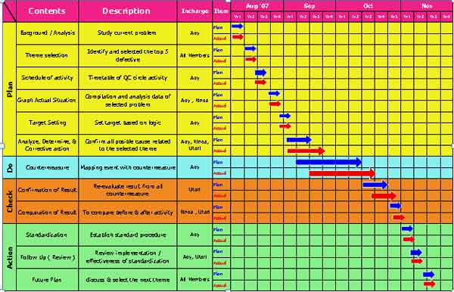

#### Sample Operating Model (for Finance)

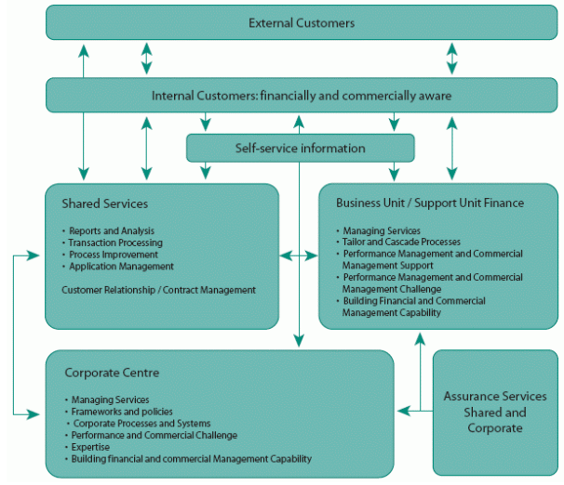

## UML Documentation

|  |  |  |
| --- | --- | --- |
| Subsystem Layering Diagram | Subsystem Component Diagram  Package Layering | Component Packaging  Application Domain |
| ASP.Net Threading | Batch Job Threading Model | Deployment Model |
| Development Environment System View | Flow Diagram | Web application Boundary |
| Data Retrieval | Data Persistence | Exception Handling |

#### USE CASE Template

|  |  |
| --- | --- |
| **Name** | The Use Case name. Typically the name is of the format <action> + <object>. |
| **ID** | An identifier that is unique to each Use Case. |
| **Description** | A brief sentence that states what the user wants to be able to do and what benefit they will derive. |
| **Actors** | The type of user who interacts with the system to accomplish the task. Actors are identified by role name. |
| **Organizational Benefits** | The value the organization expects to receive from having the functionality described. Ideally this is a link directly to a Business Objective. |
| **Assumptions** | Any statements assumed to be true about the system (or about another related system) for the system to function and execute this specific Use Case. |
| **Frequency of Use** | How often the Use Case is executed. |
| **Triggers** | Concrete actions made by the user within the System to start the Use Case. |
| **Pre-conditions** | Any states that the system must be in or conditions that must be met before the Use Case is started. |
| **Post-conditions** | Any states that the system must be in or conditions that must be met after the Use Case is completed successfully. These will be met if the Main Course or any Alternate Courses are followed. Some Exceptions may result in failure to meet the Post- Conditions. |
| **Main Course** | The most common path of interactions between the user and the system.  1. Step 1  2. Step 2 |
| **Alternate Courses** | Alternate paths through the system.  AC1: <condition for the alternate to be called>  1. Step 1  2. Step 2  AC2: <condition for the alternate to be called>  1. Step 1 |
| **Exceptions** | Exception handling by the system.  EX1: <condition for the exception to be called>  1. Step 1  2. Step 2  EX2 <condition for the exception to be called>  1. Step 1 |

## AGILE Tool

|  |  |  |
| --- | --- | --- |
| Burn down |  | Burn Up |
|  | Chart (Gantt) vs Task Board | Coaching |
| Planning – Remember the Future | Planning Prune the Product Tree | Planning Sppedboat |
| Persona | Planning Poker | Story Map  Scrum Board |
| Timeline (problem analysis) | Value Based | Wideband Delphi |

|  |  |  |  |  |
| --- | --- | --- | --- | --- |
| Iteration Burndown Excel | JIRA Team Scrum Board | **Team Scrum Board** | | Kanban |
| CA Clarity Kanban, backlog, chart | | | Planview Burndown, metrics | |

## Requirements Management Life Cycle (RMLC)

#### Requirement Artifacts

|  |  |  |  |  |  |  |  |  |  |
| --- | --- | --- | --- | --- | --- | --- | --- | --- | --- |
| **Project Management**   * High-level Estimation * Detailed Estimation * WBS * Project Charter | **Business Requirements**   * Business Scope * BRD document * Risk Catalogue * Glossary * Context & Use case | **Software Requirements**   * Requirements Catalogue * Business Rule Catalogue * Software specification * Change request * Report specification | **Asset Management**   * HW configuration * Task Report * System to task traceability * System to individual traceability * License configuration * Issues Traceability | **Domain requirements**   * Data dictionary * Translation document * File layout report * Data flow diagram | | **Business Processes/ Use cases**   * High-level use case * Detailed use case * Swimlane diagram * Flowchart * User manual | **Agile**   * Product backlog * Sprint backlog * User story catalogue | **Traceability**   * Requirements * Process * Role to data * Role | **Test cases**   * Field definition * Field validation * Functional test * UAT * Integration |
| Requirement Skills | | | | |  | | | | |

#### Requirements Fast Facts

|  |  |
| --- | --- |
| **Techniques to Trigger Thoughts** | |
| Use various tools as a starting point in requirements gathering sessions as opposed to starting from a blank slate.  **List of Questions -** Prepare a list of questions ahead of time to use as a general guide for the session.  **Use Cases –** Use cases describe the system from the point of view of the user using the system. They provide an easy format for all people to quickly grasp the system’s functionality. Draft a use case to work from.  **Existing System -** When working with an existing system, use it to trigger ideas quickly. Have the user walk through how they do the task now in the system. Talk about what users do and do not like about the system. Look at screen shots if you do not have the application handy.  **Whiteboard -** Because visualizing the system or UI improves comprehension for many people, always use a whiteboard to sketch out ideas. Capture use cases, sketch out user interfaces or draw process flows on the whiteboard.  **Screen Mockups -** For applications with user interfaces, start with mockups of the UI. Wire frames are simple black and white boxes and text, specifically not focused on look and feel. Use paper, PowerPoint, or a whiteboard to draw the UIs. | |
| **Questions to Ask When Developing Use Cases** | |
| **Description**  ► What is the actor’s goal?  ► What are the high level actions the actor will need to take to reach that goal?  **Frequency of Use**  ► How many times per minute, hour, or day will this Use Case be executed?  **Actor**  ► Who uses the system (what is their job)?  ► What other systems will interact with this system?  ► Who or what provides information to the system?  ► Who or what receives information from the system?  **Trigger**  ► What event causes this Use Case to happen?  ► What actor initiates this Use Case?  **Preconditions**  ► What conditions must be true before this Use Case can begin?  ► What state is the system in before this Use Case can begin? | **Post Conditions**  ► What conditions must be true when the Use Case ends?  ► What state will the system be in at the end of the Use Case?  **Main Course**  ► How does the actor interact with the system?  ► What does the system do at this step (present options, display data, execute a process)?  ► What does the system do next?  ► What does the actor do next?  ► Is there part of this Use Case that is another Use Case called by multiple other Use Cases?  **Alternative Courses**  ► If X doesn’t happen, what should happen?  ► What other possible actions can the user take at each step?  **Exceptions**  ► What possible error conditions exist at each step of the main course?  ► What are the interrupts that can happen at any time?  ► If the user cancels out at any step, what should happen? |
| **Preparing for Facilitated Sessions** | **Tips for Reviewing Requirements** |
| **Prepare a list of questions**  ► Allows you to start out on a strong note to get the group thinking  ► You don’t have to follow the questions as a script, but make sure to check the list at the end of the session to make sure you got everything  **Determine goals & agenda in advance**  ► Define the goals and scope of the meeting based on an overall plan of sessions  ► Prepare an agenda and send it out to everyone to give attendees context ahead of the meeting  ► Example goals for a meeting:  ► Complete the last bits of missing detail  ► Define a work flow  ► Determine business rules  ► Invite the appropriate people  ► Communicate session times well in advance  ► Sessions are most effective with no more than 6-10 people  ► Limit sessions to no more than 2 hours in length | ► Factor in time differences  ► International review cycles may take several days  ► Maintain version control of documentation  ► Ensure that everyone is reviewing the same requirements  ► Use a requirements management tool or document management tool (like SharePoint)  ► Be aware of cultural differences  ► Some people may hesitate to disagree  ► Document identified issues  ► In most cases, the original author is the best person to make changes to the requirements |
| **REQUIREMENT TYPES AND EXAMPLES**  **Business Objective** measureable target that specifies when the business problem has been solved. *[Increase revenue from the 20-40 year old professional demographics by 25%]*  **Feature** short-form description of area of functionality that solution will ultimately include to meet the business objectives. *[Quick re-generation for one passenger, Updateable profiles]*  **Functional** behavior or capability that the solution can provide irrespective of any qualifiers. *[The system shall allow the user to search for guest itinerary by Guest Last Name, Guest First Name, and/or Confirmation Number.]*  **Availability** Desired “up time” during which system and data are available for use. *[The system shall be available between 6AM and 10PM ship time, inclusive, every day of the week.]*  **Design and Implementation Constraints–** Restrictions on the options available to the development team. *[The system shall use an Oracle database to store data.]*  **Documentation –** Descriptions of any expected supplemental information, including its purpose, desired contents, level of detail, and formatting. *[The system shall provide context sensitive help that takes the user to a help topic specific to the screen in focus which describes how to use each control and data field on the screen.]*  **Emotional –** Describe the user’s feelings about the experience with the system, including where and when the emotions should be felt, and how they vary over time. *[The system shall elicit a fun feeling for the passenger when they view the physical outputs from the system.]*  **Flexibility –** How much effort is needed to add or change capabilities within the product *[The system shall allow for the addition of new fields of interest with no more than 2 hours of effort]*  **Hardware Interfaces–** Characteristics of each interface between the software system and the hardware components supported by the system. *[The system shall be able to upload digital photographs directly from a digital camera to attach to the passenger profile.]*  **Legal –** System constraints that are required by law. *[The system shall not display any information the passenger marked as confidential on the passenger profile.]*  **Logical Database –** Any information that is required to be placed into a database, including data relationships, field types, frequency of use, integrity constraints and accessing capabilities. *[The system shall maintain a history of passenger suggestions.]*  **Memory Constraints –** Constraints on the system based on memory usage. *[The client shall run on a system with 500 KB of memory, utilizing no more than 30% of the available system memory resources at any time.]*  **Operations –** System behaviors to support and operate the system. *[The system shall notify the administrator users by email and pager if the database server becomes unavailable.]*  **Performance –** The speed with which the system accomplishes specific actions under specified conditions. *[The system shall regenerate and display one passenger’s updated suggestions within 5 seconds of receiving the update request.]*  **Portability –** Ability to migrate from one platform to another or one machine to another. *[The system shall be designed such that the client runs in Windows XP now and in Windows Vista without code changes when the cruise ship upgrades its systems.]*  **Reliability –** Specified period of time and conditions for which the software must execute without a failure. *[The system shall operate without critical failure for a consecutive 72 hour period with 20 users simultaneously performing their common tasks. (See test plan for definitions of “critical failure” and “common tasks.”)]*  **Reusability –** How easily a component of the system can be used by another system. *[The system’s components to update the passenger profile shall be usable in the next release of the Passenger Tracking system.]*  **Robustness –** Expected behavior when there is invalid data, defects, or unexpected errors. *[The system shall inform the user of the issue and allow the user to continue working offline if the primary database server becomes unavailable.]*  **Security –** Behaviors to protect the software from accidental or malicious access, use, modification, destruction, or disclosure. *[The system shall store all passwords using 128 bit encryption.]*  **Site Adaptation –** Behaviors necessary to support customization of the product specific to where it will be installed or used, including details of the customizations, globalization, and localization. *[The system shall display all time stamps in the cruise ship’s local time.]*  **Software Interfaces –** Characteristics of each interface between the software system and other software components of the system or other systems. *[The system shall support using the Event Schedule system’s data to match passenger interests to available programs.]*  **Testability –** Behaviors of the system necessary to support testing the system. *[All user interface components must react to scripted input from the testing tool exactly as if the user input the scripted data or command.]*  **Usability –** Defines the ease with which end user classes can perform specific tasks with the software. *[The user interface shall allow users to regenerate the passenger suggestions from within two clicks after updating their profile information.]* | |